**PRODUCT PRICE DISPLAY USING ULK INTERFACES**

**Ashok Murugesan**

Senior Assistant Professor/IT, Rajalakshmi Institute of Technology

**I.Kailasa Eswaran**

UG Student/B.TECH(IT), Rajalakshmi Institute of Technology

**M.Durairaj**

UG Student/B.TECH(IT), Rajalakshmi Institute of Technology

**Abstract :-**-

* This Project enables the user to choose their favorite product in an easy and efficient way.
* The User will be provided with a set of statements asking him/her to touch the colour corresponding to their choice.
* Once the user has placed their order, the character LCD will display the name of product that has been selected.

**INTRODUCTION:**

The idea of our project is to display the product and also its price so that it can be used for shopping purposes. We are using UTLP kit in order to execute our idea. The main key components involved in the project are five ULK interfaces which helps in displaying the result in character, number , led format This Project enables the user to choose their favourite product in a easy and efficient way.The User will be provided with a set of statements asking him/her to touch the color corresponding to their choice. Once the user has placed their order, the character LCD will display the name of product that has been selected.

**FLOW CHART:**

start

Colors will be displayed

Touch any color ,to view the name and its price

stop

**UNIFIED LEARNING KIT**

ULK is a printed circuit board that has several interfaces such as LED, LCD, Graphical LCD, Touch and 7 segment LED. This kit will be used to execute the idea at preliminary level. For the preliminary execution of our idea, we considered the Graphical LCD part to be user side interface and Character LCD part to be care taker side interface.

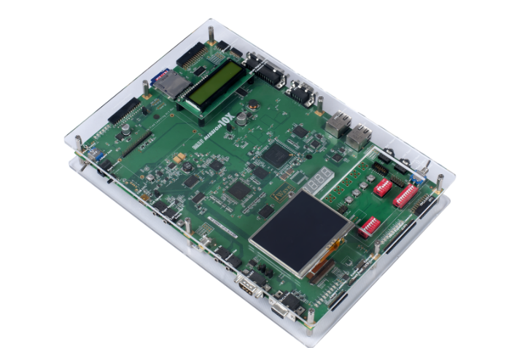

**CLCD**

The Character LCD are ideal for displaying text. They can also be configured to display small icons but the icons must be only 5×7 or smaller than that. If you look closely, you can see the little rectangles where the characters are displayed. Each rectangle is a grid of pixel. They are a fast way to have a project show status messages.

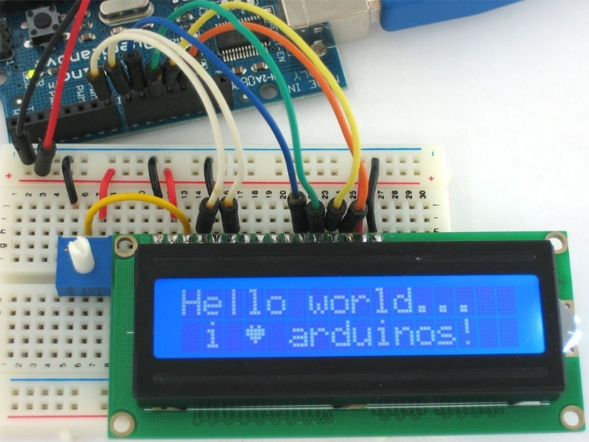

**GLCD**

Graphical LCD are different from ordinary LCD. It can be used to display monochrome images, custom text in different fonts. When compared to Character LCD, Graphical LCD has 8,192 dots which is equal to 1,024 pixels using this we can display a character in a size which we need. The Graphical LCD is controlled by two KS0108 controllers. A single KS0108 controller is capable of controlling 4,096 dots, so for controlling a Graphical LCD, we need two KS0108 controller. It is further divided into two equal parts. First half from 1 – 64 coloumbs is controlled by first KS0108 controller. The second KS0108 controlls the second half from 64 – 128 coloumbs. Each half I further divided into eight pages of equal sizes. Each page size is 8 rows and 64 coloumbs. Therefore each page contains 512 dots.

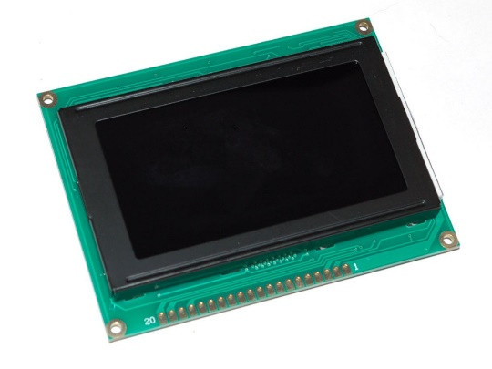

**OPERATIONS OF ULK IN NORMAL MODE:**

Commands to be done in ULK:

The 7 Segment LED displays the amount of the selected product.

The GLCD displays four different colours ,which denotes four different products.

By clicking any colour in GLCD the user can view the name of the particular product in CLCD.

#include "macros.h"#include<ulk.h>

int main(void) PROGRAM_ENTRY;

struct PIXEL

{

unsigned int x;

unsigned int y;

};

extern struct PIXEL pixel;

extern struct PIXEL ulk_proc_touch_spi_enable(void);

extern struct PIXEL ulk_proc_touch_spi_poll(void);

extern void ulk_proc_touch_spi_disable(void);

int main()

{

ulk_cpanel_printf("Select the PRODUCTS \n GREEN -PENDRIVE \n RED - BACKCASE\n BLUE -FLIPCOVER \n BLACK - TEMPER GLASS");

ulk_fpga_7seg_led_enable();

ulk_fpga_clcd_init();

ulk_fpga_clcd_display_on();

ulk_fpga_clcd_display_clear();

ulk_fpga_clcd_cursor_home();

int cg=0,cd=0,cn=0,cb=0,count=0,ig=0;

int i=0,j=0,k,l=0, *address = 0x80500000;

for(i=0;i<120;i++)

{

for(j=0; j<160; j++)

{

*(address+(i*320+j)) = 0xff0000;

}

}

for(i=120;i<240;i++)

{

for(j=0; j<160; j++)

{

*(address+(i*320+j)) = 0x00ff00;

}

}

for(i=0;i<120;i++)

{

for(j=160; j<320; j++)

{

*(address+(i*320+j)) = 0x0000ff;

}

}

for(i=120;i<240;i++)

{

for(j=160; j<320; j++)

{

*(address+(i*320+j)) = 0x000000;

}

}

ulk_proc_touch_spi_enable();

}

The above code is used to produce the desired output.

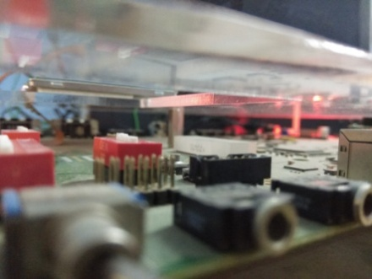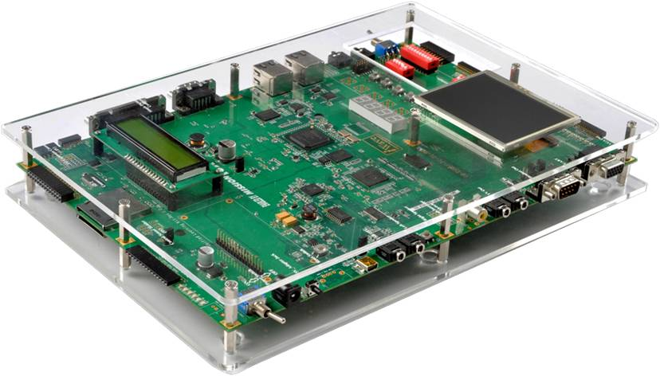

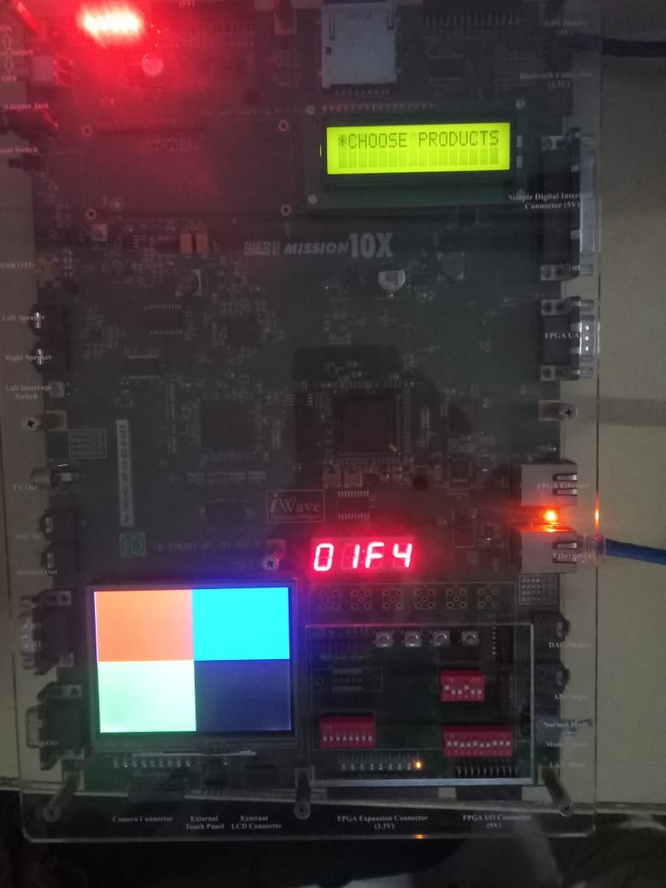

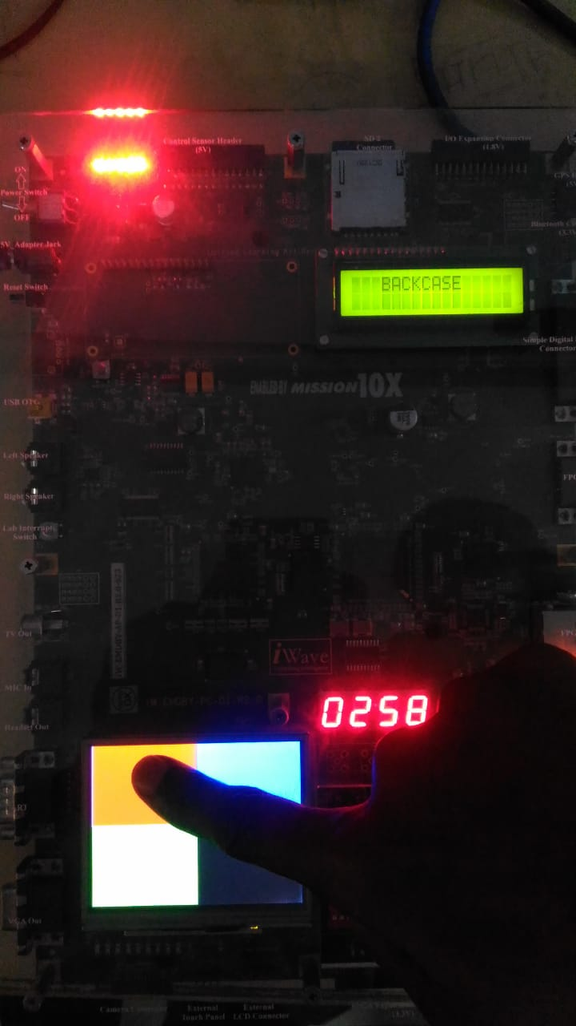

**CONCLUSION:**

The PRODUCT PRICE DISPLAY was created successfully after studying all the features of UTLP and as a result the we can avoid wastage of time,for choosing a product and its price enquiry.

**FUTURE WORKS**:

In future, this project can be enhanced by adding “ORDERING” feature. .We can further incorporate “PAYMENT” feature too. The 7 segment display could also be used to display no of pieces/items in ordering part. The display displays an acknowledgement message as a symbol of successful ordering.

**REFERENCES:**

[1] Wipro UTLP - ULK Lab Manual.

[2] http://www.iwavesystems.com